|  |
| --- |
| University of Sussex, Life Sciences |
| Rewilding: The Effect of Large Herbivores. |
| **Literature Review** |

|  |
| --- |
| 196175  12-13-2018 |



Contents

Rewilding and Its Difficulties 2

Definitions & Techniques 3

Baselines 4

Restoration 8

Rewilding Britain 10

Large Herbivores 12

Research 15

Conclusion 18

References 20

# Rewilding and Its Difficulties

Human interference on the earth is currently dominating the media, stressing the importance of conservation as we face the loss of habitats and the extinction of many species through unbalanced ecosystems. An ecosystem, as the Gaia theory states, is defined as an ecological, complex, interconnected network of living and non-living organisms interacting with one another and their physical environment [1,2]. Conservation has predominantly been focused on saving specific species and suffering landscapes, trying to prevent further decline in biodiversity [3,4]. Although it aims to protect endangered nature, it does not provide a reasonable or sustainable future for both humans and wildlife as it can lead to an imbalance in ecosystems [5]. For example, the loss of grey wolves (*Canis lupis*)at Yellowstone caused a trophic cascade. Elk (*Cervus canadensis*) populations rocketed due to lack of predatory pressure, reducing the plant diversity as they did not need to move around for protection, which led to the loss of Willow which beavers relied upon to survive [6].

Rewilding offers a more restorative approach to conservation [4]. The term ‘rewilding’ has recently been popularized by Monbiot’s book *Feral* (2014), where he talks about his need to reinvigorate the wild again [7,8]. The dictionary definition of rewilding is to “restore an area of land to its natural, uncultivated state” [9,10]. In essence, it requires the restoration of natural ecosystems although there is debate as to what “natural” means. Moorhouse & Sandom (2015) suggested any description involving rewilding could be perceived as ‘natural’ although others disagree as some cases require further assistance beyond the initiation [10]. An example can be seen in Water Vole (*Arvicola amphibious*) conservation, of how difficult it can be to achieve a ‘natural’ ecosystem without interference [10]. They outline three options in how Britain could improve Water Vole conservation. The first option is to not interfere and allow nature to take its course. However, American Mink (*Neovison vison*) are only in the UK due to previous human introduction. The second option was to carry out selective Mink removal, alongside Water Vole reintroductions but high interference from humans would have been needed to measure population levels. The final option was to cull the Mink, but much of the land that was considered Water Voles’ natural habitat is now used for agriculture. This would require human made habitats, again, making it unnatural [10]. This is one of many problems’ conservationists, like Monbiot (2014), are faced with when researching the best way to implement rewilding methods. Among those questions are “where to start?” and with “what species?” [7,10].

## Definitions & Techniques

A recommended starting point is to clearly define rewilding. The term can be interpreted and broken down into varying applicable techniques, as seen in *Table 1* [11,12].

|  |  |  |  |
| --- | --- | --- | --- |
|  | **Term** | **Definition** | **Example** |
| **Rewilding** | Trophic Rewilding | Introductions to restore top-down trophic interactions [13]. | Introducing a predator/ top-of-the-food chain animal. |
| Active Rewilding | Allowing natural processes to regain dominance [14]. | Removing all signs of human interference before allowing passive rewilding to take place. |
| Passive Rewilding | Little to no human interference [15,16]. | Often occurs in abandoned agricultural land. |

**Table 1.**Definitions of different types of Rewilding often seen in research [9–13]*.*

The abandonment of agricultural land has increased across Europe and the UK, presenting an excellent opportunity to restore ecosystems and prevent any human and/or wildlife conflict [18,19]. However, there have been debates about whether reintroducing species to abandoned lands is really a form of passive rewilding as it requires it to “reclaimed” by humans first to initiate the process [20,21].

### Baselines

When investigating how to best restore a land to its natural state, an ecological baseline should be considered as it will influence the image of the final product. Paleocology has been extremely informative when looking at the historical pasts of landscapes, from information on individual species to whole ecosystems and how they responded to the changing climates [22]. Rewilding baselines look at how ecosystems worked in varying degrees of human interference [13]. It does not aim to recreate those ecosystems, but use them as a guide to restore the land to a healthier state [13]. This is done by identifying the species that were likely to be present then, then looking at the current closest living relative and considering their eligibility, and the density they should occur [12]. This research has produced vital evidence that has been used to enhance “long-term sustainable management practices” and can be developed to be flexible in preparation of any potential changes within ecosystems [22]. Three identified baselines are the Pleistocene, Holocene and the Anthropocene. *Figure 1* shows how each of the epochs are distinguished by varying degrees of human impact.

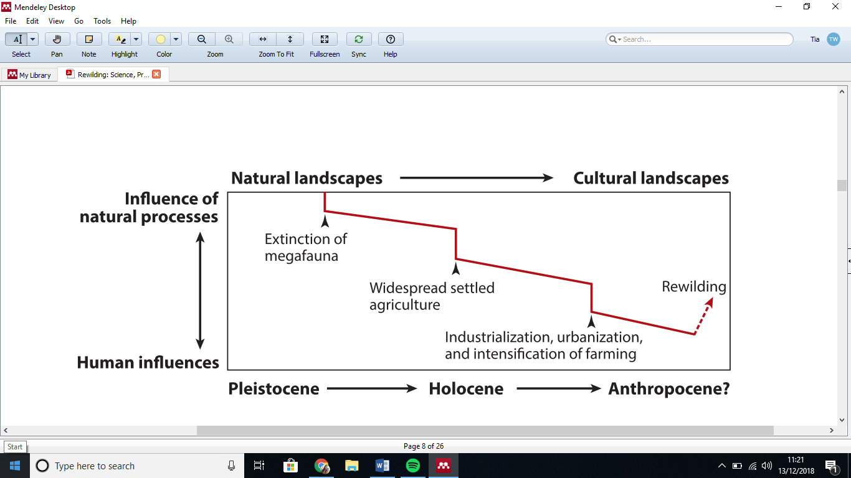

**Figure 1**. A visual showing how land has changed with varying human interference throughout the different epochs. Taken from reference 15.

“Pleistocene rewilding” was conceived by Donlan (2005) [23]. The Pleistocene era was thought to be untouched by humans. Theory suggested manipulating the current ecosystem by reintroducing closely related large vertebrates to the area. The theory stems from the idea that there was a large loss of megafauna from approximately 2.5 million to 11.7 thousand years ago from today [24–28]. By reintroducing previous-related species, it would change the current ecosystem by re-instating natural processes and begin to protect wildlife within the eco-system. Although it has been disputed that areas like North-America and Australia suffered the loss of large vertebrates due to human interference rather than natural selection [13,25,29,30]. Thus, questioning how accurate our knowledge of this time period is and whether it would be applicable to today

A more reasonable baseline for rewilding would be the “Holocene” (approximately 11 thousand years before current). It predominantly focuses on an era before farming was fully established but human interference began to negatively impact the global environment [17,31]. The Holocene provides information about the megafauna that were recently native to large areas and allows us to consider reintroducing very close relatives or the same species [11,32]. Schlaepfer (2005) points out that if large herbivores were to be reintroduced to areas like North-America as Donlan (2005) suggested, it would have large economic and ecological costs for our societies now [23,33–35]. As humans has claimed a lot of land for agricultural use, fences would have to be put up to keep out the varying sizes of herbivore species [34]. Further, climate change has caused a lot of environments to have changed at an alarming rate, meaning it may not be suitable for species that may be considered for reintroduction [34,35].

The most recent epoch is the “Anthropocene”. It is defined as the current geological age, where human life has had the most impact on the global environment [36]. However, defining our current epoch has come with resistance as geologists are arguing whether this epoch really exists as some feel we are still in the Holocene [22,37]. Their argument is based on how epochs are defined by the rock strata but others are saying the physical evidence of negative human impact is enough [37]. Despite the latter arguments, researchers have discussed how the Anthropocene is filled with opportunities for reinterpreting what is considered natural and create new landscapes with their own ecosystems [13,15]. Although, it comes filled with the current issues, such a climate change, loss of biodiversity and how it requires some human intervention to restore ecological processes such as species reintroduction [8,15,22,26].

A study using historical beetle data was able to reconstruct the abundance of large herbivores in Great Britain during the Pleistocene and Holocene, before and after high megafauna extinctions took place [38]. During the Pleistocene, there were indications of a high population of large herbivores along with a mosaic of closed-forest and wood-pasture vegetation. Whilst the early Holocene showed evidence of a closed forest vegetation, indicating a low herbivore population. The results support the idea of large herbivores being a key driver , as argued by Vera (1994) (refer to Rewilding Britain), for vegetation dynamics as they have the potential to promote plant diversity, as seen by the reduction of richness with fewer herbivores [38,39].

Other research was able to see the megaherbivore species that have gone extinct from the tundra through paleontological history and find the closest living relative alive now in hopes to reintroduce them [40]. Reindeer (Rangifer tarandus) and Muskox (Ovibos moschatus) were found to be the closest physical relative to the previous tundra species. They theorized that with increasing temperatures, thermophilic species will begin to invade the tundra. To prevent this, they suggested an assemblage of related-herbivores should be reintroduced to the tundra as they could theoretically prevent some of the side effects of climate change through grazing - influencing the carbon storage in the soil [40].

It must be noted that there are large debates as to how accurate all of the definitions and baselines listed above are to the concept of rewilding, as the majority of techniques require human interference throughout the process, whether it be specie reintroduction to reclaiming the land [10,19–21]. To give a categorical definition of the techniques used is difficult as they tend to overlap. Research argues that the lack of agreement of what rewilding means shows there is not a clear aim on how it should benefit nature and fails to acknowledge potential consequences [19]

## Reintroductions and Restoration

Restoring species and plants into their “native” habitats is seen consistently throughout the different definitions of rewilding [8]. The key concept of connectivity relates to ecosystems, in that every species has the potential to influence many others. “Top-down” and “bottom-up” achieve this through “biological processes (e.g. predation, competition and mutualism) and physiochemical process (e.g. improving or limiting influences of water, temperature and nutrients)” [27].

Top-down processes start at or close to the top of the food web with predators and herbivores, working its way down (commonly called trophic cascades), whilst bottom-up starts from the bottom of the food web, such as plants (refer to *figure 2*).

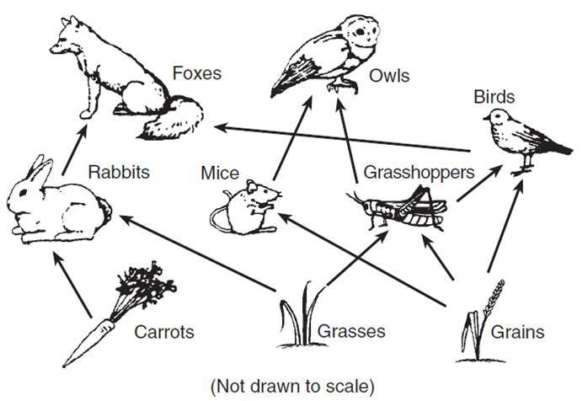

**Figure 2.** Adapted example of a food web [46].

PLANTS PREDATORS

A combination of these processes can create vast and diverse ecological conditions, providing for the biodiversity of the land. A well-known example of trophic cascading is the reintroduction of wolves into Yellowstone National Park. The wolves had an impact on the behaviour of herbivores, preventing “over-grazing”, which allowed the recovery of vegetation, growth of trees, stability of soil and the changing shape of the rivers, making them an ecosystem engineer [8,32,47,48]. Over 20 years, the ecosystem of Yellowstone has been able to restart itself and welcome other species back such as beavers, bison, a wide range of fish among plenty of other species [8,47]. Most of them also being ecosystem engineers in that they can have a large impact on the richness of the land [48]. This has become a leading example to many other countries, like Britain, as to what can be achieved through reintroducing different species of plants and animals.

Huge success has been found in specie reintroduction in North-America. The most important grazer was the bison, which was seen to be an ecosystem engineer [77]. Bison perform wallowing behaviour which creates craters of compacted soil with high disturbance. It has been found that abandoned wallows have rich Anthropod and plant populations, improving the biodiversity of the land, thus making bison important candidates for rewilding in North-America [47,77]. Large herbivores are excellent natural disturbances as they help restore and evolve the ecosystems around them.

Another example of successful herbivore introduction was the Eurasian beaver (Castor fiber) to an area in Scotland [78]. After 12 years the plant biodiversity had increased by 148%, those associated with high moisture and light conditions increasing and nitrous plants decreasing. This occurred due both grazing and waterlogging by the beavers, areas of which changed the most. This longitudinal study shows the positive effects of rewilding with large herbivores [78].

There are few successful specie reintroductions as almost 70% of specie reintroductions have failed due to lack of consideration [19]. Meta-analysis research has shown that we are still learning how food webs interact with each other as it has been shown that their interaction varies dependent on environmental context [19,27,41,42]. Although we have the means to study the historical environmental pressures on a species, that has not evolved, in a similar environment today, it still requires too many assumptions to be accurate [13,43,44]. This means it is not predictable what will happen if a species is introduced to an environment, irrelevant to how novel it may be or how carefully planned [19,45]. Researchers have recognised the lack of empirical data in specie reintroduction and suggest creating a framework for success to the new environments, rather than abandoning the idea [13,29,30].

Future research should consider how multi-functionality contributes to ecosystem dynamics and biodiversity. An example study uses quantitative measures to assess biodiversity using selected species and three identified ecosystem services [49]. This is a good model to encourage future research to investigate the current ecosystem at work before considering any specie reintroduction.

# Rewilding Britain

Rewilding landscapes in Britain has become a popular topic, especially since Frans Vera challenged Clement’s theory of succession, which states that if Britain’s landscapes were left untouched, they would be predominantly closed-canopy forests [39]. This would mean the largest and tallest plants that can survive in the climatological conditions would be the most predominant in the fight for light [39]. Vera challenges this idea using paleoecology and suggests that the pre-Neolithic period would be a suitable baseline [16] . He states that if that was the case, then there would not be so much pollen evidence of Oak and Hazel trees in the fossil records which do not survive in closed forests [50]. The historical idea of Britain having inherited a “half-open” landscape is generally accepted but it is not known to what extent how open it may have been [16]. Vera further supports his argument with the use of large herbivores being a driving force behind the vegetation cycle, causing the change in mosaic systems in Britain’s landscapes through natural disturbance like grazing and browsing (refer to *figure 3*). Increasing evidence has also come to light of open-ground taxa being present and being underestimated due to poor mid-Holocene fossil records [50]. Evidence can also be seen in modern plants and how they have evolved their defenses against plant predators [51]. With the increasing abandonment of farming lands across Europe, an excellent opportunity for rewilding is presented [52].

Cycle begins again.

**Figure 3.** Adapted diagram of Succession theory, taken from [53].

Looking back into the history of mammals in Britain, there is evidence of bison (Bison), Hippopotamuses (Hippopotamus amphibius) and Lions (Panthero leo) but that was before the ice-age, after which they did not return [54]. Vera’s model suggests that the largest herbivores to exist in Holocene Britain were Aurochs and Tarpan, the latter being lost soon after [39,54]. Aurochs alone would not be able to keep the landscape half-open as Vera suggested, so research has turned to the past and compared current feeding styles and digestions to those of their ancestors, the “natural” species of the past [39,54]. In theory, it should show how natural disturbance through grazing and browsing may produce a shifting mosaic system [39,54]. By comparing them, research hopes to reveal whether large herbivores were the key driving force behind Britain’s half-open landscape and if their living relatives are a potential pathway to restore Britain’s nature as well as other locations around the world [16,39,55,56].

## Large Herbivores

Britain’s paleobiology records can reveal what types of megafauna and plant species were present during the different epochs by looking at plant density and construction [38,57]. To verify any assumptions, evidence can be found bu looking to herbivore’s complex digestive systems, as vegetation is more difficult to digest and extract nutrients from. Herbivores can be split into different digestive systems (refer to table 2).

|  |  |  |
| --- | --- | --- |
| **Digestion System** | **Description** | **Example Species** |
| Monogastric (Hindgut fermentation) | Monogastric digestors have one, enlarged gut area in the cecum/colon that house large communities of bacteria to help digest and breakdown the cellulose (refer to figure 4). | Horses, Pigs, Rhino |
| Ruminant (Foregut fermenter) | Pre-gastric chamber made up of four compartments. Retrieves food from one compartment, rechews it then disperses it into another compartment for fermentation with the use of bacteria that is acquired from their parents into separate chambers within the rumen before being digested (refer to figure 4). | Cattle, Deer, Sheep, Hippopotamus |

**Table 2.** Description and examples of different herbivore digestive systems [51,55,58–62]

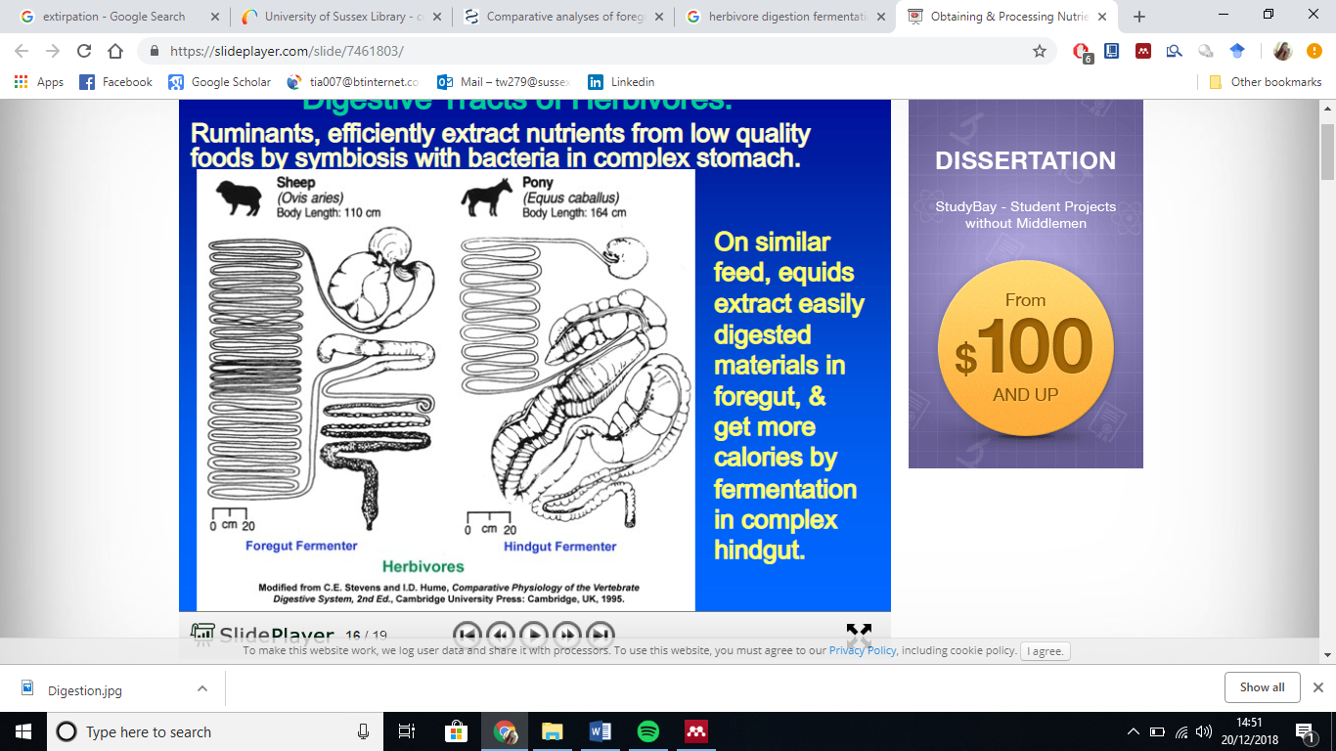**Figure 4.** Comparative diagram of foregut and hindgut fermenter digestion systems [60,62].

Ruminators are then split into three feeding styles, as seen in table 3. These would present how natural disturbance though grazing and/or browsing would affect landscape structure.

|  |  |  |  |
| --- | --- | --- | --- |
| **Feeding Type** | **Description** | **Holocene Britain** | **Present Day** |
| Bulk-roughage feeders | * Large rumens * Ferment large quantities of foliage over long period of time (not often of high nutrition) * Tend to be grazers and live in open fields, eating grass | Aurochs | Cattle, Sheep and Fallow Deer |
| Concentrate Selectors | * Small rumens * Cannot tolerate large amounts of fibre. Rumination is less important * Eats high cell and low cell wall contents * Browsers, eat little and often | Roe Deer, Elk | Roe Deer, Muntjac |
| Intermediate Feeders | * Shift feeding behaviour dependent on plant availability * Graze and browse * Tend to be herd-living species with a variety of habitats | Red Deer | Red Deer, Sika, Chinese Water Deer, Goat |

**Table 3.** Adapted table from Bullock (2009). Shows what each type of feeder is and examples of animals that are most commonly known for the feeding habit in Holocene and current Britain [39,51,54,55,63–65].

Large herbivores’ eating habits and behaviours are important because if Vera is correct in thinking they were the key driving force behind the mosaic system then with careful consideration, they could be the key to successful rewilding attempts in Britain [16,39]. Although, some physical traits and/or behaviours may differ between the species.

Simulations were run on current open-landscapes and found that present intermediate grazers conserved the openness and promoted Oak and Beech forest growth. Simulations without herbivores lost all plant biodiversity [66]. Intermediate grazers were excellent at maintaining semi-open landscapes as they did not need additional forage during winter and their browsing thinned tree canopies, even in unattractive foraging sites, thus maintaining habitats for threatened species from dry grasslands [66].

# Research

Extensive grazing has been a primary focus, looking at how grazing affects the surrounding ecosystem. Extensive grazing is used as an agricultural production system where herbivores are kept in field to keep it fertilized for farming and removing any over-dominant plant species, thus increasing biodiversity [67,68]. In western Europe, countries have dedicated sites to observing the influence like the New Forest in England, the Junner Koeland in the Netherlands, Öland in Sweden, Mols Bjerge in Denmark and the Borkener Paradies [69]. These lands are important as they provide a site for grazing experimentation, furthering food web knowledge to improve the biodiversity crisis, especially in forests in the UK [70].

Although, there is a common problem now, especially in Scotland, where fields are being overgrazed [67,71]. The population density of large herbivore species appear to play a major role in how successful they are at enrichening the plant biodiversity [68]. Some may suggest that the complete removal of a species from an over grazed area would fix the problem quickly but that is not necessarily true [71]. Results have found that after removing sheep from plots of land, established approximately 50-70 years ago, did not improve the ecosystem on a short-term scale as the plants and the soil chemistry became undigestible. It was approximated that it would take up to 50 years to return the plant and soil acidic levels back to a fertile state before the ecosystem could be recovered, so rewilding should be thought as long-term solution with the help of other approaches [71].

Other conservation sites have taken on a naturalistic grazing approach, where the animals are left alone to regulate the ecosystem. Oostvaardersplassen in the Netherlands have defined this approach’s key features as: no specified herbivore density, grazing animals are assumed to be key drivers, and the aim is to keep the process as natural as possible [69,72]. This means there is no human interference, even when food is running low and illness is not treated [69]. However, as mentioned before as to whether this is a “passive” rewilding approach, it has caused controversies regarding animal welfare. It has been argued that as humans have reintroduced species back to the area, they should take responsibility for them rather than letting nature “manage” them. A compromise was made that any weaker, ill animals found that were unlikely to survive would be shot, to reduce suffering [20,21].

An experiment was carried out in Oostvaadersplassen investigating how likely saplings would establish in the natural environment with free-roaming large herbivores [73]. Reduced herbivore access was adequate to allow the saplings to grow but was better in areas that had been grazed previously, as they had more access to light than the other areas. Herbivores being used in rewilding was deemed to be successful if grazing refuges were present as they allowed for establishment [74,75]. From these results, it was suggested that one-time human interference of creating grazing refuges may be beneficial in the long-run [73].

If threatened plant species are not given time to recover, herbivores can cause further damage [75,76]. In this study, the threatened species of plant was preferred by the herbivores due to it being appetizing compared to the other taxa available. Further supporting the importance of considering grazing refuge when rewilding, so the plant has a chance to establish itself [75].

Much of the present research is often based off short-term studies which is not representative of the benefits of rewilding [75,79]. Many gaps within research were found due to the topic being dominated by short-term studies, such as; how herbivore pressure has indirect effects on the ecosystems around them, how different herbivores differ in responses, and the mechanisms driving trophic cascades. Research within rewilding would benefit from using adaptive approaches and a mix of experimental and natural studies to begin to understand how herbivores effect ecosystems and whether they would be suitable for a particular rewilding location, especially with climate change [56,79,80].

Although, rewilding is not a new concept but has only recently been given a popular name that is attached to research controversy. An early example of “rewilding” being the reintroduction of the White Rhinoceros in South Africa [81,82]. Relevant information can be extrapolated from previous areas of ecological research that is not exclusively labelled as rewilding [80].

# Conclusion

Overall, rewilding as a conservation tool has good intentions with sound scientific theory behind it. Rewilding in practise is where aims and methods become unclear as there is not one universal definition or method for application. Although studies have been able to distinguish the different interpretations of rewilding, a sound and accepted model should be created. However, it is understood that a universal method may not be applicable to all sites, thus different application methods should be tested in a variety of contexts to enable to sound empirical studies to show if rewilding is as successful as it has been in some cases. This also applies to the aspect of specie reintroduction as there are few studies that show how disruptive it can be to local ecosystems. Plans and controls should be mandatory in upcoming rewilding reintroductions. This includes checking for any possible contaminations via parasites or pests when introducing a species to a new environment.

These studies would also allow for further understandings of the delicacy of food webs. Knowledge of ecosystem relationships has many gaps as they are far more complex than many ecologists believe.

In conclusion, rewilding is still an evolving conservation tool that has a lot of potential for battling climate change and species extinction. Further research needs to be taken to fill the gaps of knowledge that previous studies have uncovered and to unite the ecological community in working together to clearly define what rewilding means in a scientific and practical context.

# References

1 ecosystem | Definition of ecosystem in English by Oxford Dictionaries. . [Online]. Available: https://en.oxforddictionaries.com/definition/ecosystem. [Accessed: 12-Dec-2018]

2 Lovelock, J. (2003) The survival of Afro-American physicians in 1990 and beyond: Inaugural address. *Nature* 426, 769–770

3 Sandbrook, C. (2015) What is conservation? *Oryx* 49, 565–566

4 Lawton, J.H., Brotherton, P.N.M., Brown, V.K., Elphick, C., Fitter, A.H., Forshaw, J., Haddow, R.W., Hilborne, S., Leafe, R.N., Mace, G.M., Southgate, M.P., Sutherland, W.J., Tew, T.E., Varley, J., & Wynne, G.R.Lawton, J.H., Brotherton, P.N.M., Brown, V.K, G.R. (2011) Making Space for Nature: A review of England’s Wildlife Sites and Ecological Network. *Environ. Law* 13, 1–8

5 Valiente-Banuet, A. *et al.* (2015) Beyond species loss: the extinction of ecological interactions in a changing world. *Funct. Ecol.* 29, 299–307

6 Staff (2011) , Wolf Reintroduction Changes Ecosystem. , *My Yellowstone Park*. [Online]. Available: https://www.yellowstonepark.com/things-to-do/wolf-reintroduction-changes-ecosystem. [Accessed: 21-Dec-2018]

7 Monbiot, G. (2014) *Feral: Rewilding the land, the sea, and human life*,

8 Townsend, M. (2016) Rewilding - Keeping the brand integrity. *Ecos* 37, 29–34

9 rewild | Definition of rewild in English by Oxford Dictionaries. . [Online]. Available: https://en.oxforddictionaries.com/definition/rewild. [Accessed: 12-Dec-2018]

10 Moorhouse, T.P. and Sandom, C.J. Conservation and the problem with ‘natural’ – does rewilding hold the answer? , *Geography*, 100. (2015) , 45–50

11 Corlett, R.T. (2016) , Restoration, Reintroduction, and Rewilding in a Changing World. , *Trends in Ecology and Evolution*

12 Bull, J. *Rewilding Knowledge Hub Bibliography-Version 1.0*,

13 Svenning, J.-C. *et al.* (2016) Science for a wilder Anthropocene: Synthesis and future directions for trophic rewilding research. *Proc. Natl. Acad. Sci. U. S. A.* 113, 898–906

14 Sandom, C. *et al.* (2013) Rewilding. In *Key Topics in Conservation Biology 2* pp. 430–451

15 Lorimer, J. *et al.* (2015) *Rewilding: Science, Practice, and Politics*,

16 Hodder, K.H. *et al.* (2009) Can the pre-Neolithic provide suitable models for rewilding the landscape in Britain? *Br. Wildl.* June, 4–15

17 Corlett, R.T. (2016) , Restoration, Reintroduction, and Rewilding in a Changing World. , *Trends in Ecology and Evolution*, 31, 453–462

18 Loth, A.F. and Newton, A.C. (2018) Rewilding as a restoration strategy for lowland agricultural landscapes: Stakeholder-assisted multi-criteria analysis in Dorset, UK. *J. Nat. Conserv.* DOI: 10.1016/j.jnc.2018.10.003

19 Nogués-Bravo, D. *et al.* Rewilding is the new pandora’s box in conservation. , *Current Biology*, 26. (2016) , R87–R91

20 Lorimer, J. (2015) *Wildlife in the Anthropocene: Conservation after Nature*, Regents of the University of Minnesota.

21 Royle, C. (2015) *WILDLIFE IN THE ANTHROPOCENE: CONSERVATION AFTER NATURE*,

22 Mcdowell, M. (2017) Biodiversity Conservation and Environmental Change. Using Palaeoecology to Manage Dynamic Landscapes in the Anthropocene Lindsey Gillson. Oxford University Press, Oxford, 2015. xiv + 215 pp. Price £34.99. ISBN: 978-0-19-871304-3 (paperback, also available. *Austral Ecol.* 42, e5–e5

23 Donlan, J. (2005) Re-wilding North America. *Nature* 436, 913–914

24 Malhi, Y. *et al.* (2016) Megafauna and ecosystem function from the Pleistocene to the Anthropocene. *Proc. Natl. Acad. Sci.* 113, 838–846

25 Sandom, C. *et al.* (2014) Global late Quaternary megafauna extinctions linked to humans, not climate change. *Proc. R. Soc. London B Biol. Sci.* 281, 20133254

26 Svenning, J.-C. *et al.* (2016) Science for a wilder Anthropocene: Synthesis and future directions for trophic rewilding research. *Proc. Natl. Acad. Sci.* 113, 898–906

27 Estes, J. a *et al.* (2011) Trophic downgrading of planet Earth. *Science* 333, 301–306

28 Pettorelli, N. *et al.* (2018) Making rewilding fit for policy. *J. Appl. Ecol.* 55, 1114–1125

29 Rubenstein, D.R. and Rubenstein, D.I. (2016) From Pleistocene to trophic rewilding: A wolf in sheep’s clothing. *Proc. Natl. Acad. Sci.* 113, E1–E1

30 Svenning, J.-C. *et al.* (2016) Reply to Rubenstein and Rubenstein: Time to move on from ideological debates on rewilding. *Proc. Natl. Acad. Sci. U. S. A.* 113, E2-3

31 Benayas, J.M.R. and Bullock, J.M. (2015) *Vegetation restoration and other actions to enhance wildlife in European agricultural landscapes*,

32 Kitchener, A.C. (2012) Re-wilding Ireland: restoring mammalian diversity or developing new mammalian communities? *Irish Nat. J.* 2009, 4–13

33 Schlaepfer, M.A. (2005) Re-wilding : a bold plan that needs native megafauna Indian players in some of IT and biotech ’ s top teams NIH moved quickly to help researchers after Katrina System to rank scientists Evolution was fine , just not in the case of humans. *Nature* 437, 2005

34 Smith, C.I. (2005) Re-wilding : introductions could reduce biodiversity. *Nature* 437, 2005

35 Connelly, T.L. (1966) The American Camel Experiment: A Reappraisal. *Southwest. Hist. Q.* 69, 442–462

36 Anthropocene | Definition of Anthropocene in English by Oxford Dictionaries. . [Online]. Available: https://en.oxforddictionaries.com/definition/anthropocene. [Accessed: 13-Dec-2018]

37 Stromberg, J. (2013) , What Is the Anthropocene and Are We in It? , *Smithsonian Magazine*. [Online]. Available: https://www.smithsonianmag.com/science-nature/what-is-the-anthropocene-and-are-we-in-it-164801414/. [Accessed: 18-Dec-2018]

38 Sandom, C.J. *et al.* (2014) High herbivore density associated with vegetation diversity in interglacial ecosystems. *Proc. Natl. Acad. Sci. U. S. A.* 111, 4162–7

39 Vera, F.W.M. (1994) *GRAZING ECOLOGY AND FOREST HISTORY*, CABI Publishing.

40 Olofsson, J. and Post, E. (2018) Effects of large herbivores on tundra vegetation in a changing climate, and implications for rewilding. *Philos. Trans. R. Soc. B Biol. Sci.* 373, 1–8

41 Gruner, D.S. *et al.* (2008) A cross-system synthesis of consumer and nutrient resource control on producer biomass. *Ecol. Lett.* 11, 740–755

42 Hillebrand, H. *et al.* (2007) *Consumer versus resource control of producer diversity depends on ecosystem type and producer community structure*, 104

43 Caro, T. (2007) The Pleistocene re-wilding gambit. *Trends Ecol. Evol.* 22, 281–283

44 Hale, S.L. and Koprowski, J.L. (2018) Ecosystem-level effects of keystone species reintroduction: a literature review : Effects of keystone species reintroduction. DOI: 10.1111/rec.12684

45 Saul, W.-C. and Jeschke, J.M. (2015) Eco-evolutionary experience in novel species interactions. *Ecol. Lett.* 18, 236–245

46 (2015) , Understanding our Garden Better with a Food Web. . [Online]. Available: https://desertoasisgarden.wordpress.com/2015/05/13/understanding-our-garden-better-with-a-food-web/. [Accessed: 18-Dec-2018]

47 Ripple, W.J. *et al.* (2015) Collapse of the world’s largest herbivores. *Sci. Adv.* 1, e1400103–e1400103

48 Haemig, P.-D. (2012) , Ecosystem Engineers: Organisms that Create, Modify and Maintain Habitats. , *Ecology (12)*. [Online]. Available: http://www.ecology.info/ecosystem-engineers.htm. [Accessed: 13-Dec-2018]

49 Funk, A. *et al.* (2019) Science of the Total Environment Identi fi cation of conservation and restoration priority areas in the Danube River based on the multi-functionality of river- fl oodplain systems. *Sci. Total Environ.* 654, 763–777

50 Buckland, P.C. and Buckland, P.I. (2014) Large herbivores in the wildwood and for nature tomorrow.

51 Level, I. Studying mammals : Plant predators.

52 Helmer, W. *et al.* (2015) Rewilding Europe: A New Strategy for an Old Continent. In *Rewilding European Landscapes* pp. 171–190, Springer International Publishing

53 EnviroSci No Title. , *2018*. [Online]. Available: http://envirosci.net/111/succession/succession.htm

54 Bullock, D.J. (2009) What larger mammals did Britain have and what did they do? *Br. Wildl.* 20, 16–20

55 Lyons, R. *et al.* (1996) What Range Herbivores Eat — and Why. *Coop. Ext. Work Agric. Home Econ.* DOI: 10.1590/s1516-89132013000400002

56 Olofsson, J. and Post, E. (2018) Effects of large herbivores on tundra vegetation in a changing climate, and implications for rewilding. *Philos. Trans. R. Soc. B Biol. Sci.* 373, 20170437

57 Dietl, G.P. *et al.* (2015) Conservation Paleobiology: Leveraging Knowledge of the Past to Inform Conservation and Restoration. *Annu. Rev. Earth Planet. Sci.* 43, 79–103

58 Godoy-Vitorino, F. *et al.* (2012) Comparative analyses of foregut and hindgut bacterial communities in hoatzins and cows. *ISME J.* 6, 531–41

59 Furness, J.B. *et al.* (2015) COMPARATIVE GUT PHYSIOLOGY SYMPOSIUM: Comparative physiology of digestion1. *J. Anim. Sci.* 93, 485–491

60 Stevens, C.E. (Charles E.. and Hume, I.D. (2004) *Comparative physiology of the vertebrate digestive system*, Cambridge University Press.

61 Stevens, C.E. and Hume, I.D. (1998) *Contributions of Microbes in Vertebrate Gastrointestinal Tract to Production and Conservation of Nutrients*, 78

62 Campbell, K.L. and Griffith, L. (2015) , Obtaining &amp; Processing Nutrients &amp; Relation of Animal Body Evolution to Digestion Kenneth L. Campbell Professor of Biology University of Massachusetts. - ppt download. , *University of Massachusetts*. [Online]. Available: https://slideplayer.com/slide/7461803/. [Accessed: 20-Dec-2018]

63 Lashley, M.A. *et al.* (2014) Collection, handling and analysis of forages for concentrate selectors. *Wildl. Biol. Pract.* 10, 29–38

64 Arispe, S. Classification of Herbivores. *Integr. Rangel. Manag. Univ. Idaho* at <http://www.webpages.uidaho.edu/range456/Class_Notes/Classification_Herbivores(Notes).pdf>

65 Cromsigt, J.P.G.M. *et al.* (2017) Rewilding Europe’s large grazer community: how functionally diverse are the diets of European bison, cattle, and horses? *Restor. Ecol.* DOI: 10.1111/rec.12661

66 Schulze, K.A. *et al.* (2018) Intermediate foraging large herbivores maintain semi-open habitats in wilderness landscape simulations. DOI: 10.1016/j.ecolmodel.2018.04.002

67 Ross, L.C. *et al.* (2016) Sheep grazing in the North Atlantic region: A long-term perspective on environmental sustainability. *Ambio* 45, 551–566

68 Olff, H.; and Ritchie, M.E. (1998) Effects of herbivores on grassland plant diversity. *Trends Ecol. Evol.* 13, 261–265

69 Hodder, K.H. and Bullock, J.M. (2009) Really Wild? Naturalistic grazing in modern landscapes. *Br. Wildl.* 20, 37–43

70 Hester, A.J. *et al.* (2000) Interactions between forests and herbivores: The role of controlled grazing experiments. *Forestry* DOI: 10.1093/forestry/73.4.381

71 Marrs, R.H. *et al.* (2018) Effects of removing sheep grazing on soil chemistry, plant nutrition and forage digestibility: Lessons for rewilding the British uplands. *Ann. Appl. Biol.* DOI: 10.1111/aab.12462

72 Staatsbosbeheer (2018) , Oostvaardersplassen. . [Online]. Available: https://www.staatsbosbeheer.nl/natuurgebieden/oostvaardersplassen/over-de-oostvaardersplassen. [Accessed: 15-Dec-2018]

73 Smit, C. *et al.* (2015) Rewilding with large herbivores: The importance of grazing refuges for sapling establishment and wood-pasture formation. *Biol. Conserv.* 182, 134–142

74 Schippers, P. *et al.* (2014) The impact of large herbivores on woodland-grassland dynamics in fragmented landscapes: The role of spatial configuration and disturbance. *Ecol. Complex.* 17, 20–31

75 Smit, C. *et al.* (2015) Rewilding with large herbivores: The importance of grazing refuges for sapling establishment and wood-pasture formation. *Biol. Conserv.* 182, 134–142

76 Velamazán, M. *et al.* (2017) Threatened woody flora as an ecological indicator of large herbivore introductions. *Biodivers. Conserv.* 26, 917–930

77 Nickell, Z. *et al.* (2018) Ecosystem engineering by bison (Bison bison) wallowing increases arthropod community heterogeneity in space and time. *Ecosphere* DOI: 10.1002/ecs2.2436

78 Law, A. *et al.* (2017) Using ecosystem engineers as tools in habitat restoration and rewilding: beaver and wetlands. *Sci. Total Environ.* 605–606, 1021–1030

79 Foster, C.N. *et al.* (2014) Effects of large native herbivores on other animals. DOI: 10.1111/1365-2664.12268

80 Bakker, E.S. *et al.* (2016) Combining paleo-data and modern exclosure experiments to assess the impact of megafauna extinctions on woody vegetation. *Proc. Natl. Acad. Sci.* 113, 847–855

81 Hansen, D.M. (2015) Non-native megaherbivores: the case for novel function to manage plant invasions on islands. *AoB Plants* 7, plv085

82 Cromsigt, J.P.G.M. and te Beest, M. (2014) Restoration of a megaherbivore: Landscape-level impacts of white rhinoceros in Kruger National Park, South Africa. *J. Ecol.* 102, 566–575